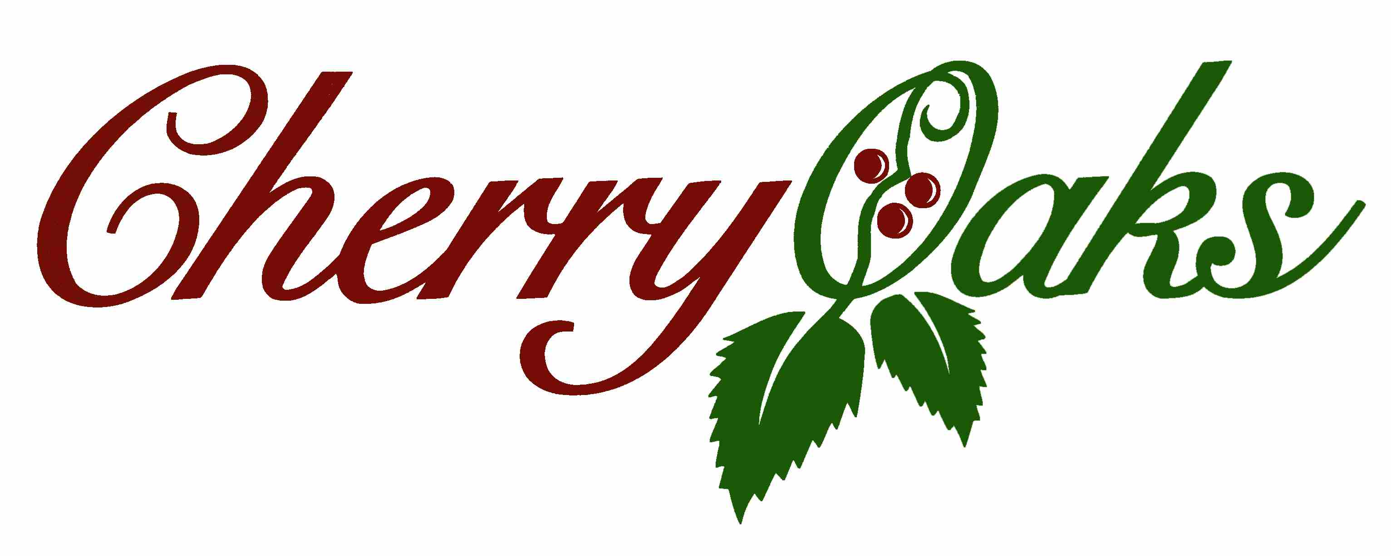
1119 N. Main St.
Cheney, Kansas 67025
Phone (316) 540-0133
Scott Johnson-Clubhouse Manager
2025 Tournament Agreement

Tournament Name: __________________________________________ Number of Players: _________________

Tournament Coordinator: _________________________ Home Phone: __________________________________

Cell Phone: _________________________________ Work Phone: _______________________________

Mailing Address: _______________________________________________________________________________

Email Address: _______________________________________ Tournament Date Requested: _______________

Tournament Start Time Requested: ________________ Tournament Format: _______________________________

Please Check Services Desired:

- Registration Table
- Scorecards with Names and Starting Holes
- Players Names and Starting Holes on Golf Carts
- Scoreboard Services
- Rules Sheets
- Meal Provided by Cherry Oaks
- Meal Catered in
- Other, Please Specify: ________________________________________________________________

Please Check Desired Hole Contests: (for each, please specify which holes)

- Closest to the Pin(s): _________________________________________________________________

- Longest Drive in the Fairway: __________________________________________________________

- Longest Putt Made: __________________________________________________________________

- Other: _____________________________________________________________________________

Please Note: This tournament agreement is valid only for groups of 60 players (15 teams) or larger and accommodates “shotgun” starts only. If your event doesn’t have 15 teams, you will be charged up to 15 teams for a shotgun tournament, so if your event only has 13 teams then you will be charged for 15 teams. All tournaments will be booked on a first come, first serve basis. Tournaments may be booked in a manner to support maximum usage of the golf course at given time. In the event your group has less than 60 players, we will be happy to make arrangements for a block of tee times. The 15 teams will be strictly enforced.

Price Per Person

Monday – Thursday Friday - Sunday
$56.00 60 players $59.00
$51.00 61 – 80 players $54.00
$46.00 81 – 100+ players $49.00

Price Includes Green Fee, Cart Fee, Range Balls, Scoreboard / Scorecards / Cart Tags / Administrative

Tournament Starting Times
March – April 9:00am
May – August 8:00am
Sept. – Oct. 9:00am

Tournament Responsibilities
The tournament coordinator will provide Cherry Oaks with a typed copy of pairings by group at least 5 days in advance of the tournament date.

Liability
The tournament coordinator shall be responsible for any and all damages to any equipment or property on the golf course.

Food and Beverage
The tournament coordinator agrees to purchase all beverages from Cherry Oaks, no “donated”alcoholic beverages will be allowed on the property. Personal coolers with alcoholic beverages and the like containing alcoholic beverages may NOT be brought onto the premises or into the clubhouse and if Cherry Oaks sees that this rule is being violated, the alcoholic beverages will be confiscated and those responsible may be asked to leave the premises.

This provision will be strictly enforced!!!!

Cherry Oaks offers a couple of food menu choices (see page 4). We also offer a variety of snacks throughout the day.

If in the event you choose to use a catering service or bring in pre-prepared food, there will be a $1.00 per person surcharge. In this instance, Cherry Oaks will not be responsible for napkins, utensils, plates or the like.

A beverage cart will be made available on the course during the tournaments. Only Cherry Oaks employees will be allowed to distribute food and beverages from this cart. I.E., Cherry Oaks will provide its own drivers, however, event photographers and support staff are able to ride along if desired. Any beer that remains in the any of the coolers provided by Cherry Oaks will be charged to the tournament and will be the responsibility of the tournament coordinator.

Gift Certificates and Prizes

The tournament coordinator agrees to check Cherry Oaks pricing on all golf related prizes. The Clubhouse Manager is available to help with the prize selection and gift certificate options. Donated golf related prizes are acceptable.

Cherry Oaks will always donate a round of golf for four players (carts not included) to tournaments hosted on site. (60 player tourney minimum)

Dress Code
The tournament coordinator will be responsible for the participants to be properly attired. Proper attire is defined to be regular and customary apparel worn by golfers. Collared shirts are preferred for men. Soft spikes or tennis shoes are required, no metal spikes or cowboy boots.

Player Guarantee
A $200 deposit is required. The tournament coordinator agrees to guarantee the number of players at the time the agreement is submitted. The tournament coordinator may change the number of players as it becomes necessary, but is responsible for full payment of all players unless cancelled at least 8 days in advance. Failure to cancel tournament at least 8 days in advance will lose the $200 deposit.

Inclement Weather and Uncontrollable Events
In the event of inclement weather and/or other uncontrollable events, Cherry Oaks reserves the right to deal with each tournament as an independent event. Cherry Oaks reserves the right to make “on the spot” judgment calls in dealing with the given situation. The Clubhouse Manager and/or his staff will make every effort to reschedule or rectify the situation in an equitable manner.

Extra Golf Carts
In the event that a tournament will require more carts than are owned by Cherry Oaks, the extra golf carts will be rented by Cherry Oaks and in turn, rented to the tournament at no profit and no expense to Cherry Oaks Golf Course.
This provision will be strictly enforced

Final Arrangements
Once the tournament date and times are secured, the tournament coordinator or representative should make periodic contact with the Clubhouse Manager to finalize all details of the event.

COVID Related Acknowledgments and Release

The requestors of this Tournament (the “Releasors”) hereby request to utilize the services and facilities of the Cherry Oaks Golf Course, operated by the City of Cheney, Kansas. The Cherry Oaks Golf Course cannot prevent individuals from becoming exposed to, contracting, or spreading COVID-19 while utilizing the Cherry Oaks Golf Course’s facilities or services. It is not possible to prevent against the presence of the disease. Therefore, individuals choosing to utilize the Golf Course’s services or facilities may be exposing themselves to and/or increasing their risk of contracting or spreading COVID-19.

In this context, the Releasors understand that it is not only possible, but likely, that tournament participants will be in contact with citizens of the community at a distance closer than 6 feet. Releasors also understand and acknowledge the risks associated with such contact, including but not limited to those risks associated with the recent COVID-19 outbreak. However, despite these risks, Releasors desire to rent the facilities described in this Agreement and in exchange do hereby agree to waive any claims for personal injury or property damage against the City of Cheney and its officers, employees, agents, invitees and volunteers that in any way emanate from or relate to the tournament’s rental or use of the facilities or services referenced hereunder. Additionally, the tournament agrees to indemnify and hold harmless the City of Cheney and its officers, employees, agents, invitees and volunteers from any and all such claims referenced in this paragraph. The tournament acknowledges and agrees that said indemnification and hold harmless commitment includes but is not limited to the duty to defend the City of Cheney and its officers, employees, agents, invitees and volunteers from and against any and all such claims referenced in this paragraph.

Payment Options
Payment is expected in full when services are rendered. Please select one of the options below.

- Will pay the day of event with Credit Card
- Will pay the day of event with Check
- Will pay the day of event with Cash
- Request Invoice
- Other

Signature: ___________________________________________ Date: ______________

Cherry Oaks 2025 Food Options

Option 1: Burgers and Hot Dogs Served Buffet Style ($15.00 per person)
(To be served following play. Additional fees will be required if served throughout the event.)
Includes the following:
Hamburgers Baked Beans
Hot Dogs Cookies
Potato Salad Appropriate Condiments

Option 2: All Day Hot Dog Buffet ($12.50 per person)
This is an option for an event that would like food available throughout the event. It enables participants to grab a hot dog anytime they pass the Pavilion. The buffet comes with hot dogs, buns, condiments and chips.

